Estimations
Paper clip: 1g | Large apple: 150g | 2L fizzy drink: 2kg | Large bag of potatoes: 7kg
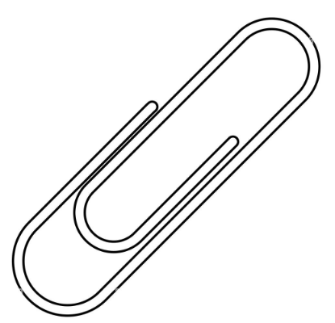 | 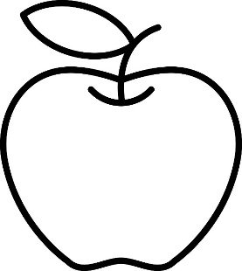 | 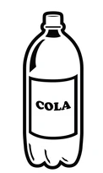 | 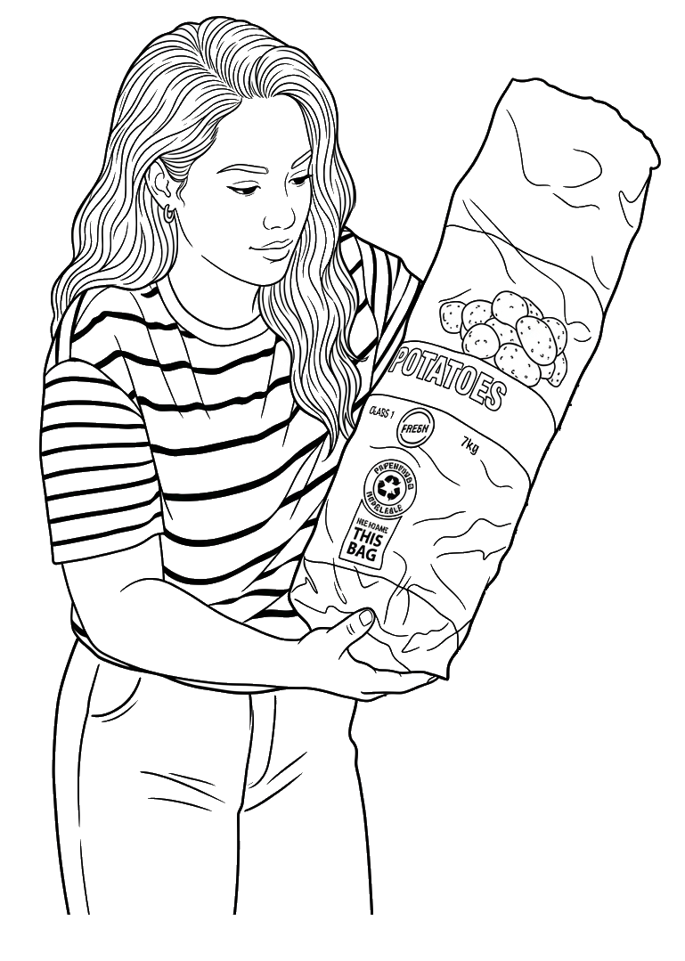

Average weight of a grade 6 student: 40kg | Weight of an adult:  80-100kg | Weight of a car: 1000kg | Weight of an elephant:  6000kg
 |  | 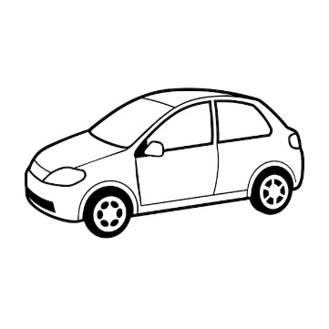 | 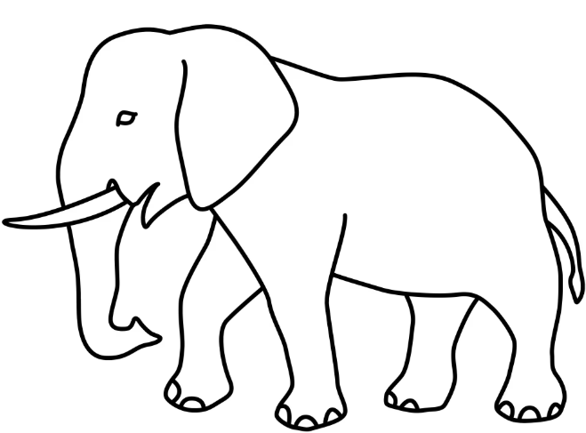

1. Estimate the mass of:
1.1) | Mathematics textbook. | 8 g | 800 g | 8 kg | 80 kg
1.2) | Single chicken egg. | 60 g | 600 g | 6 kg | 60 kg
1.3) | Full-grown domestic cat. | 45 g | 450 g | 4,5 kg | 45 kg
1.4) | Single paperclip. | 1 g | 10 g | 100 g | 1 kg
1.5) | Slab of chocolate. | 1 g | 100 g | 1 kg | 10 kg
1.6) | Standard building brick used to build a house | 3 g | 30 g | 300 g | 3 kg
1.7) | Standard bicycle. | 12 g | 120 g | 1,2 kg | 12 kg
1.8) | Standard loaf of bread. | 7 g | 70 g | 700 g | 7 kg
1.9) | Fully grown male lion. | 1,9 kg | 19 kg | 190 kg | 1 900 kg
1.10) | Farm tractor. | 270 g | 2,7 kg | 27 kg | 2 700 kg

Mass and weight: instruments
Bathroom scale  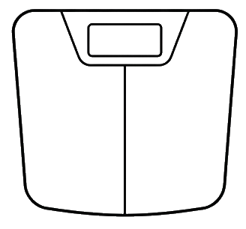 | What it does: Measures heavier objects and people sitting or standing directly on top of it.  Use:  - Yourself: Stepping on the scale to check how many kilograms you weigh.  - Luggage: Checking if a packed travel suitcase is under the airline's weight limit before going on a trip.
Balance scale  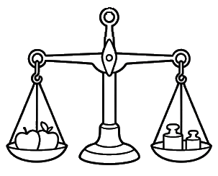 | What it does: It acts like a seesaw; we put the object that we want to weigh on one side and then we put weights on the other side. When both sides balance, then we would have found its weight by adding up all the weights used.  Use:  - Market Fruit: Balancing a bag of apples against heavy metal weights at a farm stand  - Spices or Grains: Measuring out a scoop of rice or coffee beans at a market.
Kitchen scale  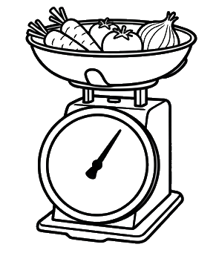 | What it does: Measures light to medium-weight ingredients and everyday food items, usually in grams or small kilograms.  Use:  - Baking: Measuring $250\text{ g}$ of flour or butter so a cake recipe turns out perfectly.  - Small Liquids/Packages: Checking the weight of a bottle of juice or a small parcel you want to post.
Spring scale  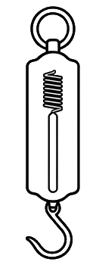 | What it does: Uses a stretchy spring and a hook underneath to measure weight or the force of pulling an object.  Use:  - Fishing: Hanging a freshly caught fish from the hook to see how heavy it is.  - Force: demonstrates the force needed to pull an object
Triple Beam Balance  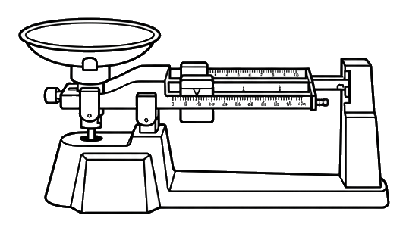 | What it does: Uses three sliding metal weights along labelled bars (beams) to find very precise measurements down to tiny fractions of a gram.  Use: Finding the exact mass of a small rock, coin, or metal key in a science lab.

Questions
2. | What are the readings of the instruments?
 | a) | 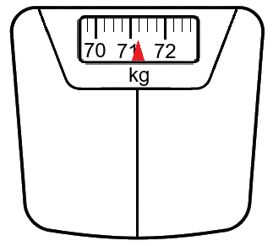 | b) | 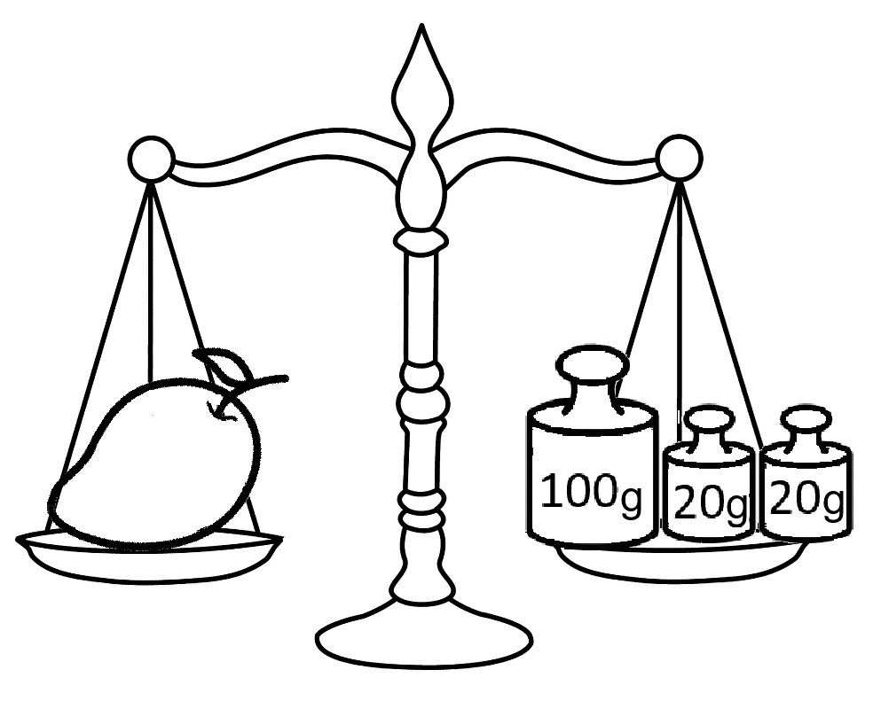 | c) | 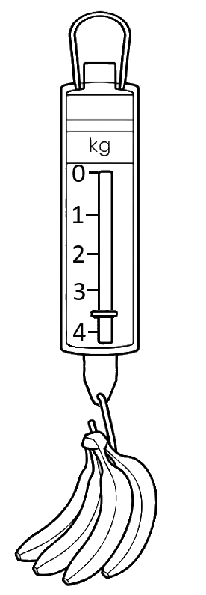
 | Reading: _________________________ |  | Reading: _________________________ |  | Reading: _________________________

 | d) | 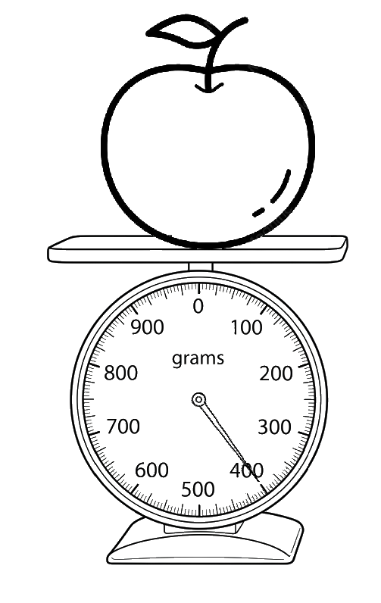 | e) | 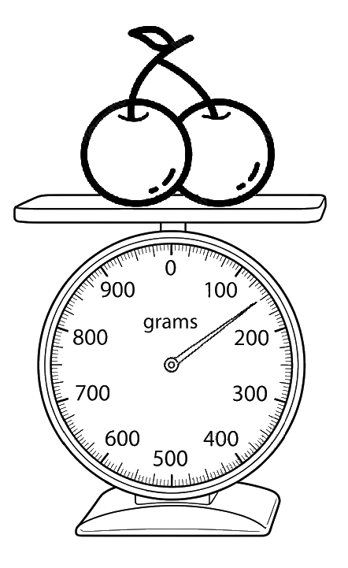 | f) | 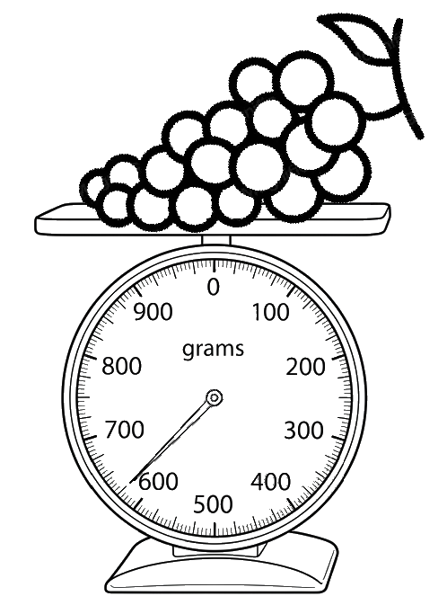
 | Reading: _________________________ |  | Reading: _________________________ |  | Reading: _________________________

3. | Answer the questions
 | 3.1) | Elizabeth steps onto the scale and weighs 48 kg. Next, she weighs her cat separately, and it weighs 4 kg.  If she steps onto the scale while holding her cat, what combined weight will the scale display?  Answer: ____________________________________________________________________________________________________
 | 3.2) | Tom wants to find the weight of a chocolate slab using a balance scale.  - First, he places the chocolate slab on one side of the scale, and one 50g weight and three 20g weights on the other side. The scale tips toward the weights because they are too heavy.  - Next, he replaces one of the 20g weights with a 10g weight, and the scale perfectly balances.  What is the weight of the chocolate slab?  Answer: ____________________________________________________________________________________________________

Conversion
Remember, “Horse to fly, multiply” and “Fly to horse, divide of course”
Mass Conversion Chart
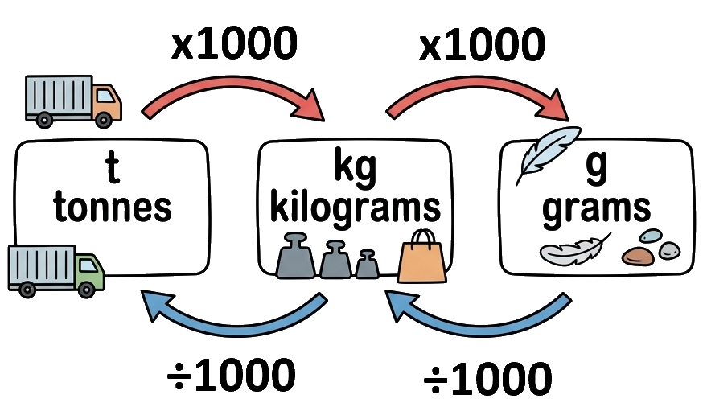

4. Convert the following units

- 1,3 kg = ________________ g
- 4 500 g = ________________ kg
- 0,08 kg = ________________ g
- 2 t = ________________ kg
- 630 g = ________________ kg
- 3,75 t = ________________ kg
- 15 210 g = ________________ kg
- 8 400 kg = ________________ t
- 0,5 t = ________________ g
- 2 845 g = ________________ kg
- 0,45 kg = ________________ g
- 7 800 g = ________________ kg
- 5,2 t = ________________ kg
- 950 g = ________________ kg
- 12 500 kg = ________________ t
- 0,006 t = ________________ kg
- 3 050 g = ________________ kg
- 1,8 t = ________________ g
- 420 kg = ________________ t
- 0,075 kg = ________________ g

Fraction questions
Method is to first convert the mass into smaller units first
Example: $3 \frac{1}{2}kg$ = ___________ g?

First 1kg = 1000g
For the whole numbers, there are 3 kg, so it’s 3000g
For the fraction, what is a half of 1000g? It’s 500g
The total is then $3000g+500g = 3500g$

Note: if $\frac{1}{4}$ kg is 250g, then 3 quarters are ($\frac{3}{4} = 3*250g=750g$) OR you can convert it to a decimal: $\frac{3}{4}kg=\frac{75}{100}kg=0.75kg=750g$
5. | Find the unit conversions
 | a) | $2\frac{1}{2}kg$ into grams  Whole part: __________________________________ g  Fraction part: _________________________________ g  Total: ___________________________ g | b) | $1\frac{1}{4}kg$ into grams  Whole part: __________________________________ g  Fraction part: _________________________________ g  Total: ___________________________ g
 | c) | $3\frac{1}{10}t$ into kilograms  Whole part: _________________________________ kg  Fraction part: _________________________________ kg  Total: __________________________ kg | d) | $4\frac{3}{4}t$ into kilograms  Whole part: _________________________________ kg  Fraction part: _________________________________ kg  Total: _________________________ kg

Compare the following masses
6. Use <, > or = to compare the following. Remember we can only compare like units, so first convert them to the same unit.

- 150 g ______ 0,1 kg
- 2,5 kg ______ 2 500 g
- 450 g ______ 0,5 kg
- 3 t ______ 3 200 kg
- 0,08 kg ______ 800 g
- 1 500 kg ______ 1,5 t
- 0,75 t ______ 750 kg
- 6 200 g ______ 6,2 kg
- 0,004 t ______ 40 kg
- 850 g ______ 0,085 kg

Order the following
First convert all to the same units then compare
Example: Order the following in ascending order
$\frac{1}{2}$ kg; | 3 000g; | 2,4kg; | 150g

Remember we can only compare like units so first convert to all the same.
500g; | 3 000g; | 2400g; | 150g

Now we can order them, use the original
150g; | $\frac{1}{2}$ kg; | 2,4kg; | 3 000g;

7. | Order the following in ascending order
 | a) | $\frac{1}{2}$ kg ; 1 200 g ; 3,5 kg ; 800 g  Order: ___________________________________________________________________
 | b) | 2 500 g ; $\frac{1}{4}$ kg ; 1,8 kg ; 600 g  Order: ___________________________________________________________________
 | c) | $\frac{3}{4}$ kg ; 0,9 kg ; 2 100 g ; 600 g  Order: ___________________________________________________________________
 | d) | 5,2 kg ; 750 g ; $\frac{4}{5}$ kg ; 520 g  Order: ___________________________________________________________________

Word problems
8. Answer the following questions
8.1) | What is the total mass of 2,3 kg, 500 g and 3 kg 450 g?  Answer: ____________________________________________________________________________________________________
8.2) | What mass is 500 g less than 4,32 kg?  Answer: ____________________________________________________________________________________________________
8.3) | How much lighter is 345 g than 1,1 kg?  Answer: ____________________________________________________________________________________________________
8.4) | The heaviest mass allowed on a ride at the fairground is 55 kg. Diana's mass is 28,1 kg and Dave's mass is 27 000 g. Can they go on the ride together?  Answer: ____________________________________________________________________________________________________
8.5) | The average mass of one peach is 175 g. What is the mass of nine peaches in kilograms?  Answer: ____________________________________________________________________________________________________
8.6) | (a) The mass of eight apples is 1 200 g. What is the average mass of one apple in kilograms?  Answer: ____________________________________________________________________________________________________  (b) A 5 kg bag of apples costs R65. What is the cost of 500 grams of apples?  Hint: find the price of 1kg  Answer: ____________________________________________________________________________________________________
8.7) | Which has a greater mass: twenty-eight 35 g packets of chips or three 400 g bags?  Answer: ____________________________________________________________________________________________________
8.8) | Dried dog food comes in 5.2 kg bags. A dog eats 400 g each day. How long will the food last?  hint: convert into grams  Answer: ____________________________________________________________________________________________________
8.9) | The masses of the items in Nombulelo's shopping are 450 g, 0,25 kg, 650 g and 1,3 kg. The doctor said that she must not carry more than 4 kg. What is the heaviest mass of potatoes she can add to her bag?  Answer: ____________________________________________________________________________________________________

Mass and Weight - Worksheet Memo / Answer Key

1. Estimations
1.1 Mathematics textbook: 800 g
1.2 Single chicken egg: 60 g
1.3 Full-grown domestic cat: 4,5 kg
1.4 Single paperclip: 1 g
1.5 Slab of chocolate: 100 g
1.6 Standard building brick: 3 kg
1.7 Standard bicycle: 12 kg
1.8 Standard loaf of bread: 700 g
1.9 Fully grown male lion: 190 kg
1.10 Farm tractor: 2 700 kg
2. Instrument Readings
(Readings based on typical dial/scale markings shown on Page 3)
a) 71,25 kg
b) 150 g
c) 3.5kg
d) 400 g
e) 150 g
f) 650 g
3. Word Problems (Page 3)
3.1) $48\text{ kg}+4\text{ kg}=52\text{ kg}$
3.2) Scale balances with $50\text{ g}+20\text{ g}+20\text{ g}+10\text{ g}=100\text{ g}$
4. Unit Conversions (Page 4)
a) $1,3\text{ kg}=1\text{ 300 g}$
b) $4\text{ 500 g}=4,5\text{ kg}$
c) $0,08\text{ kg}=80\text{ g}$
d) $2\text{ t}=2\text{ 000 kg}$
e) $630\text{ g}=0,63\text{ kg}$
f) $3,75\text{ t}=3\text{ 750 kg}$
g) $15\text{ 210 g}=15,21\text{ kg}$
h) $8\text{ 400 kg}=8,4\text{ t}$
i) $0,5\text{ t}=500\text{ 000 g}$
j) $2\text{ 845 g}=2,845\text{ kg}$
k) $0,45\text{ kg}=450\text{ g}$
l) $7\text{ 800 g}=7,8\text{ kg}$
m) $5,2\text{ t}=5\text{ 200 kg}$
n) $950\text{ g}=0,95\text{ kg}$
o) $12\text{ 500 kg}=12,5\text{ t}$
p) $0,006\text{ t}=6\text{ kg}$
q) $3\text{ 050 g}=3,05\text{ kg}$
r) $1,8\text{ t}=1\text{ 800 000 g}$
s) $420\text{ kg}=0,42\text{ t}$
t) $0,075\text{ kg}=75\text{ g}$
5. Fraction Conversions (Page 4)
a) $2\frac{1}{2}\text{ kg}$ into grams:
Whole part: 2 000 g
Fraction part: 500 g
Total: 2 500 g

b) $1\frac{1}{4}\text{ kg}$ into grams:
Whole part: 1 000 g
Fraction part: 250 g
Total: 1 250 g

c) $3\frac{1}{10}\text{ t}$ into kilograms:
Whole part: 3 000 kg
Fraction part: 100 kg
Total: 3 100 kg

d) $4\frac{3}{4}\text{ t}$ into kilograms:
Whole part: 4 000 kg
Fraction part: 750 kg
Total: 4 750 kg

6. Comparing Masses (Page 5)
a) $150\text{ g}>0,1\text{ kg}$ $\left(100\text{ g}\right)$
b) $2,5\text{ kg}=2\text{ 500 g}$
c) $450\text{ g}<0,5\text{ kg}$ $\left(500\text{ g}\right)$
d) $3\text{ t}<3\text{ 200 kg}$ $\left(3,2\text{ t}\right)$
e) $0,08\text{ kg}<800\text{ g}$ $\left(80\text{ g}<800\text{ g}\right)$
f) $1\text{ 500 kg}=1,5\text{ t}$
g) $0,75\text{ t}=750\text{ kg}$
h) $6\text{ 200 g}=6,2\text{ kg}$
i) $0,004\text{ t}<40\text{ kg}$ $\left(4\text{ kg}<40\text{ kg}\right)$
j) $850\text{ g}>0,085\text{ kg}$ $\left(85\text{ g}\right)$

7. Ordering in Ascending Order (Page 5)
(Assuming missing fractions are restored as standard curriculum examples)
a) $\frac{1}{2}\text{ kg}$ $\left(500\text{ g}\right)$; $1\text{ 200 g}$; $3,5\text{ kg}$ $\left(3\text{ 500 g}\right)$; $800\text{ g}$
Order: $\frac{1}{2}\text{ kg}; 800\text{ g}; 1\text{ 200 g}; 3,5\text{ kg}$

b) $2\text{ 500 g}$; $\frac{1}{4}\text{ kg}$; $1,8\text{ kg}$; $600\text{ g}$
Order: $\frac{1}{4}\text{ kg}; 600\text{ g}; 1,8\text{ kg}; 2\text{ 500 g}$

c) $\frac{3}{4}\text{ kg}$; $0,9\text{ kg}$; $2\text{ 100 g}$; $600\text{ g}$
Order: $600\text{ g}; \frac{3}{4}\text{ kg}; 0,9\text{ kg}; 2\text{ 100 g}$

d) $5,2\text{ kg}$; $750\text{ g}$; $\frac{4}{5}kg$; $520\text{ g}$
Order: $520\text{ g}; 750\text{ g}; 800\text{ g}; 5,2\text{ kg}$

8. Word Problems (Page 6)
8.1) $2,3\text{ kg}+0,5\text{ kg}+3,45\text{ kg}=6,25\text{ kg}$ (or $6\text{ kg }250\text{ g}$)
8.2) $4,32\text{ kg}-0,5\text{ kg}=3,82\text{ kg}$ (or $3\text{ 820 g}$)
8.3) $1\text{ 100 g}-345\text{ g}=755\text{ g}$ (or $0,755\text{ kg}$)
8.4)$27\text{ 000 g}=27\text{ kg}$
Total mass: $28,1\text{ kg}+27\text{ kg}=55,1\text{ kg}$
Answer: No, because $55,1\text{ kg}$ exceeds the $55\text{ kg}$ limit.

8.5) $175\text{ g}×9=1\text{ 575 g}=1,575\text{ kg}$

8.6)
(a) $1\text{ 200 g}÷8=150\text{ g}=0,15\text{ kg}$
(b) $1kg=R13$. $\text{R}65÷2=\text{R}6,50$

8.7)
Chips: $28×35\text{ g}=980\text{ g}$
Bags: $3×400\text{ g}=1\text{ 200 g}$
Answer: Three 400 g bags have a greater mass.

8.8) $5.2\text{ kg}=5\text{ 200 g}$. $5 \text{2}\text{00 g}÷400\text{ g/day}=13\text{ days}$
8.9) Current shopping: $0,45\text{ kg}+0,25\text{ kg}+0,65\text{ kg}+1,3\text{ kg}=2,65\text{ kg}$
Max remaining capacity: $4\text{ kg}-2,65\text{ kg}=1,35\text{ kg}$ (or $1\text{ 350 g}$)

